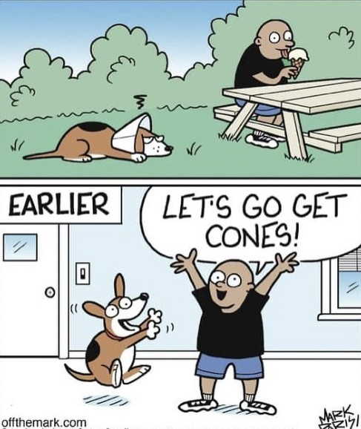  - BENGOUGH VACCINE CLINIC  Tuesday Sept 15, 2026 8:30am – 10:30am @ the town shop  Information:  This is a drop-in clinic, so no appointment is necessary.  This clinic is for both cats and dogs.  We are happy to see both new and returning patients.    If there is someone already inside with their pets, we ask that you please wait outside until they leave.
  Annual Health Examinations
  ____
  Distemper, Kennel Cough and Rabies Vaccinations
  ____
  Dewormer
  ____
  Flea and Tick Control
  Deep South Animal Clinic
  110 Railway Ave
  PO Box 387
  Ogema, SK S0C 1Y0
  (306) 459-2422

